


GUIDELINE

Project Acronym: | PEPPOL
Grant Agreement number: | 224974
Project Title: | Pan-European Public Procurement Online
ICT-PreAward - eCAT

PEPPOL_Business_Interoperability_Profile_Guideline
_Model_Version 1.01

Version: 4.0.0
Status: In use

Authors:
Peter L. Borresen ebConnect
Klaus V. Pedersen DIFI

Project co-funded by the European Commission within the ICT Policy Support Programme
Dissemination Level
P | Public | X
C | Confidential, only for members of the consortium and the Commission Services
Revision History

Revision | Date | Author | Organisation | Description
0.1 | 2010.03.26 | PLB | ebConnect | Template filled out
0.2 | 2010.05.03 | PLB | ebConnect
0.3 | 2010.05.11 | PLB | ebConnect | Chapter 4,5,6 and 7 updated
0.4 | 2010.05.20 | PLB | ebConnect | Chapter 1,2 and 3 updated.
1.0 | 2011.06.01 | KPE | Difi | Official release for Deliverable 3.4
1.0.1 | 2012.06.30 | Giancarlo De Stefano | Consip | Official release for Delivery of PEPPOL EIA Release 4

Statement of originality

This deliverable contains original unpublished work except where clearly indicated otherwise. Acknowledgement of previously published material and of the work of others has been made through appropriate citation, quotation or both.
Statement of copyright
This deliverable is released under the terms of the Creative Commons Licence accessed through the following link: http://creativecommons.org/licenses/by/3.0/.

In short, it is free to
Share — to copy, distribute and transmit the work
Remix — to adapt the work
Under the following conditions
Attribution — You must attribute the work in the manner specified by the author or licensor (but not in any way that suggests that they endorse you or your use of the work).

Table of Contents

1 Preamble 4
1.1 PEPPOL Profile Guideline status 4
2 Introduction 5
2.1 European Interoperability Framework (EIF) 2.0 model 5
2.2 CEN ISSS WS/BII Workshop 6
2.3 The PEPPOL Community 7
2.4 Audience 8
2.5 PEPPOL Profile Guideline Context 8
Figure 4 9
3 The profile concept 9
3.1 Roles and documents 10
3.2 Document flow 10
4 How to understand profiles 10
4.1 CENBII profile descriptions 10
4.2 PEPPOL profile descriptions 11
5 Profile relationships 11
6 How to implement profiles 12
6.1 Semantic interoperability in profile implementation 12
6.2 CEN ISSS WS/BII Profile 14
6.3 PEPPOL requirements for semantics interoperability 14
6.4 Semantic extentions in Peppol 15
6.5 Application of Peppol semantic extentions. 16
6.6 Using extentions in the BusDox network. 17
6.7 Applying extentions in trade 17
6.8 Interoperability testing. 18
7 eCatalogue, eOrdering and eInvoicing context 19
7.1 Organizational context 20
7.1.1 Levels in organizational interoperability 21
7.2 Organisational Issues 22
7.2.1 Process received document 22
7.2.2 Prepare document for import into ERP system 22
7.2.3 Archiving received document 22
7.2.4 Internal processing 23
7.3 Industry specific processing 23

Preamble

The objective of the PEPPOL profile guideline is to explain and guide the usage of the PEPPOL profiles.
The exchange of business documents in Peppol follows a design that enable open exchange of electronic documents. The exchange of documents contains the following main steps.
- Compliance with externals requirements, legal and organisational.
- The exchange of business information in an agreed sequence.
- The exchange of business information in the form of data with agreed semantic meaning
- The methods of delivering this data between the partners.
Peppol approaches this with an open interoperability architecture based on the European Interoperability Framework 2.0, the CEN ISSS WS/BII profiles and the BusDox transport specifications.
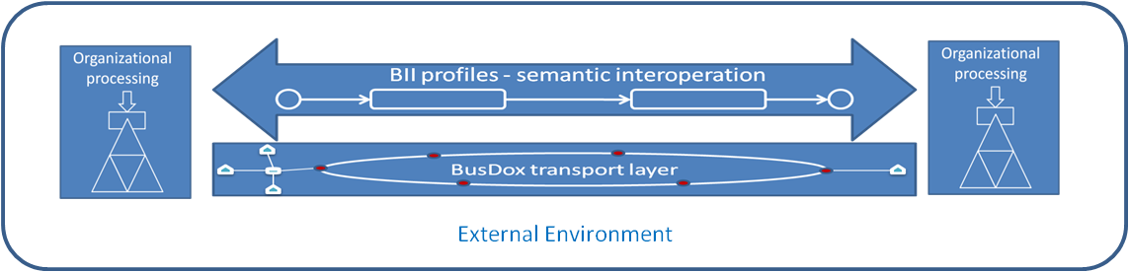
Figure 1
A PEPPOL profile is based on a CEN ISSS WS/BII profile, and brings it into context of the PEPPOL Community.

PEPPOL Profile Guideline status

Test Pilot | 1.0 | First Version of Profile
Production Pilot
Production

Introduction
The objective of a PEPPOL Profile Guidelin is to support and guide
- The use of PEPPOL Profiles for implementation of electronic commerce in a standardized way,
- thereby enabling the development of standardized software solutions,
- as well as efficient connections between trading partners
- Without case by case specification of the data interchange.
The end goal is to reduce the cost of implementing support for electronic procurement to a level that is economical even for small and medium size companies and institutions.

A PEPPOL Profile is a technical specification describing
- The Legal scope of the specification
- The Organisation/Business scope of the specification
- the choreography of the business process(es) covered, i.e. a detailed description of the way the business partners collaborate to play their respective roles and share responsibilities to achieve mutually agreed goals with the support of their respective information systems,
- the electronic business transactions exchanged as part of the business process and the sequence in which these transactions are exchanged,
- the business rules governing the execution of that business process(es), its business collaborations and business transactions, as well as any constraints on information elements used in the transaction data models
- the information content of the electronic business transactions exchanged by pointing to a given data model for each of the business transactions.
- The technical implementation of the business specifications and semantic specifications
- Relationship with the PEPPOL eSignature and Transport infrastructure

European Interoperability Framework (EIF) 2.0 model

The EIF’s goal is
- To serve as the basis for European seamless interoperability in public services delivery, thereby providing better public services at EU level
- To support the delivery of Pan-European eGovernment Services (PEGS) by furthering cross-border and cross-sector interoperability;
- To supplement the various National Interoperability Frameworks in the pan-European dimension.

A PEPPOL Profile is organised around the European Interoperability Framework (EIF) version 2.0 Interoperability model (http://ec.europa.eu/idabc/servlets/Doc?id=31597). The EIF model is divided into 4 interoperability layers. In the PEPPOL Profile context this has been further divided giving 7 layers.

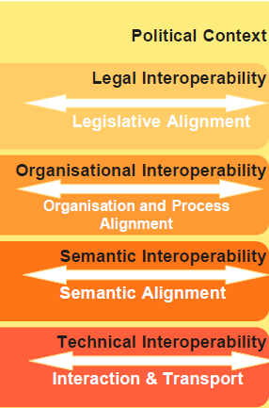 | Organisational interoperability is divided into :  - Organisation/Business Interoperability  - Process interoperability,  Technical interoperability is divided into  - Interaction (Process and Semantic implementation)  - Interaction (eSignature Validation)  - Transport

The Profile sets the scope of Legal Interoperability (Legislative Alignment) and Organisationl Interoperability (Organisation/Business Alignment). The Profile transfers the requirements resulting from the scoping into solutions on Organisational Interoperability (Process Alignment), Semantic Interoperability (Semantic Alignment), Tecnhnical Interoperability (Interaction i.e. Process and semantic implementation and eSignature validation), Tecnhnical Interoperability (Transport).

In order to comply with this profile specification, it is necessary to comply with one and each interoperability layer. On the Legal, Organisation/Business interoperability layers, this means compliance to legal and Organisation/business requirements. On Organisation-Process, Semantic and Technical interoperability layers it means compliance and use of the solution specifications.

CEN ISSS WS/BII Workshop
Business interoperability interfaces for public procurement in Europe are being established in order to
- Identify and document the required business interoperability interfaces related to pan-European electronic transactions in public procurement expressed as a set of technical specifications, developed by taking due account of current and emerging UN/CEFACT standards in order to ensure global interoperability;
- Co-ordinate and provide support to pilot projects implementing the technical specifications in order to remove technical barriers preventing interoperability.
- To facilitate implementation of electronic commerce in a standardized way, thereby enabling the development of standardized software solutions as well as efficient connections between trading partners without case by case specification of the data interchange
- Documentation of required business interoperability interfaces as profile descriptions.
- The end goal is to reduce the cost of implementing electronic commerce to a level that is economical for small and medium size companies and institutions.
A CEN ISSS WS/BII profile description is a technical specification describing business processes, i.e. a detailed description of the way trading partners intend to play their respective roles, establish business relations and share responsibilities to interact efficiently with the support of their respective information systems i.e.
- the business rules governing the execution of that business process,
- possible run-time scenarios and the business commitments achieved,
- the electronic messages exchanged as part of the business process and the
- sequence in which these documents are exchanged,
- the information content of the electronic messages exchanged.
As well as determining what documents are used, the profile restricts document content in terms of elements and the cardinality of elements. The key standardization aspect of the profile description is thus in the semantics rather than the syntax. Consequently the messages within a profile can be structured based on different message standards/syntax as long as the chosen standard contains all the necessary data elements.

A CEN ISSS WS/BII Profile covers the Organisation (Process) and Semantic layer in the EIF model. PEPPOL Restrictions or extensions to the profile might be relevant for meeting requirements on the Legal- or Organisation (Organisation/Business) layers

Figure 2 provides an overview of the profiles relevant for PEPPOL Post Awarding Profiles.
The document at hand “PEPPOL Profile 04a” is based on CEN ISSS WS/BII profile BII04.
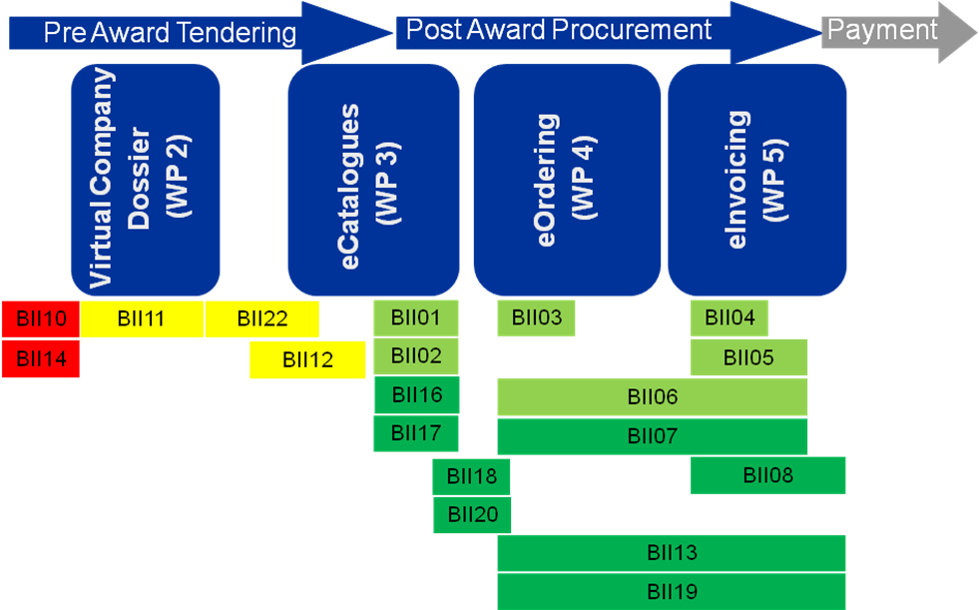
Figure 1: Overview of the relevant BII profiles for PEPPOL

The PEPPOL Community

The PEPPOL Post Award eProcurement Community is any Contracting Authority or Economic Operator that complies with one or more PEPPOL Profiles and is directly or indirectly connected to the PEPPOL Transport Infrastructure.

The PEPPOL Transport Infrastructure is creating a connection between existing Transport Infrastructures, thereby creating a 4-corner model. The set of PEPPOL SMPs (Service Metadata Publishers) and APs (Access Points) is the Core PEPPOL eProcurement Community.

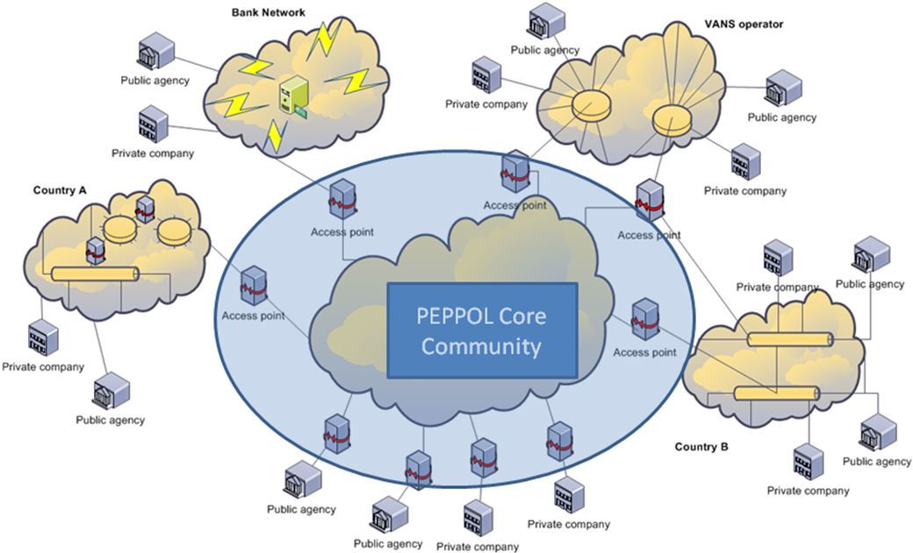
Figure 3: The PEPPOL community is connected with all its sub nets through access points.

All access points must be compliant to one or more PEPPOL Profiles on all Interoperability Layers. A participant i.e. Contracting Authority or an Economic Operator, connected to an access point is compliant to a PEPPOL profile if the access point is enabled for that profile and:
- Legal requirements are fulfilled
- Organisational (Organisational/Business) requirements are fulfilled
- Organisational (Process) solution is supported internally in the organisation
- Semantic solution is supported internally in the organisation
- Technical Interaction (Process and Semantic) implementation is handled i.e. if the infrastructure used by the participant also uses the PEPPOL profile, the participant must comply to the PEPPOL profile. If another implementation solution is used, then the Access point must convert between that solution and the PEPPOL profile format and content.

Audience
The audience for this document is stakeholders who want to be PEPPOL enabled and their ICT-suppliers who are going to fulfill the requirements from PEPPOL. That can be:
- Access point stakeholders
- Contracting Authorities
- Economic Operators

PEPPOL Profile Guideline Context
Figure 4 positions the “PEPPOL Profile Guideline”. As the figure depicts, several profile documents is part of the PEPPOL specification library. Mappings to/form the agreed PEPPOL format will be part of the provided specification. Based on the specifications, the PEPPOL reference implementation software is available in the software library. Necessary components is Schemas, Schematron implementations, transformation component and the implemented workflow in BPEL format. Additional reference implementation specifications are placed in the Reference Implementation Specification Library. Furthermore guidelines are provided to help the reader to understand PEPPOL profiles. Futher guidelines are given on how to test and validate in order to secure PEPPOL conformance and validation (Test, Conformance, Validation Guideline). The last guideline provides the developer with support in implementing reference software which is PEPPOL compliant (Software Component Guideline).

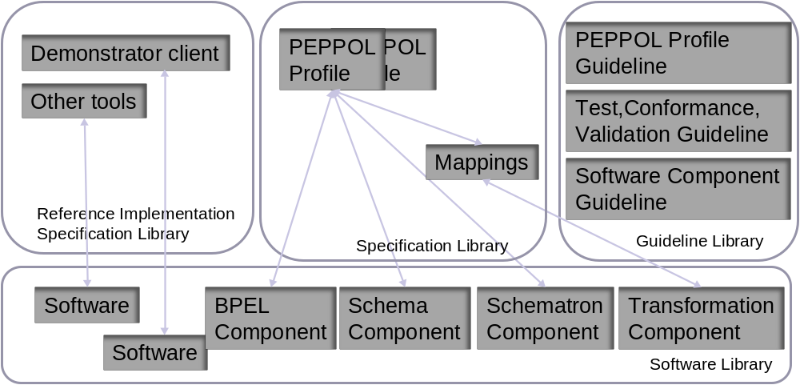

Figure 4

The profile concept
One of the core concepts of the CENBII workshop is the profile concept. CEN BII has defined a profile as “A specification of how one or more Business Processes are executed by specifying the business rules governing its business collaborations and the information content (data model) of the electronic business transactions exchanged.”

In order to support the exchange of business documents in an open and interoperable manner, the profiles within CEN BII will be described with an aim to function as an “agreement”. This is done in order to lower one of the main barriers to the efficient and effective implementation of electronic procurement; the need to entering in to bilateral agreements with each business partner. By providing precise and detailed profile descriptions an organisation implementing a profile from CEN BII can claim conformance to it. By doing so the organisation is committed to all aspects of the profile and thus limiting the need for further bilateral agreements.
In the context of the CEN BII a profile provides a detailed description of:
- The choreography of the business process(es) covered, i.e. a detailed description of the way the business partners will play their respective roles and share responsibilities with the support of their respective information systems, as well as the possible run-time scenarios and the business commitments achieved,
- The business rules governing the execution of that business process(es), its business collaborations and business transactions, as well as any constraints on information elements used in the transaction data modelsthe electronic business transactions exchanged as part of the business process and the sequence in which these transactions are exchanged,
- The information content of the electronic business transactions exchanged by pointing to a given data model for each of the business transactions.
As well as determining what business transactions are used, the profile restricts their content in terms of information elements and the cardinality of elements through data models and business rules. The key standardization aspect of the profile is thus in the semantics rather than the syntax. Consequently the business transactions within a profile can be structured based on different message standards/syntax as long as the chosen standard contains all the necessary data elements.

Roles and documents
In CENBII the defined roles in the procurement process is static and related to the documents they send and receives. In general all procurement are performed between a customer and a supplier, but theese can take the roles of e.g. Debtor and Creditor as shown in the figure below:

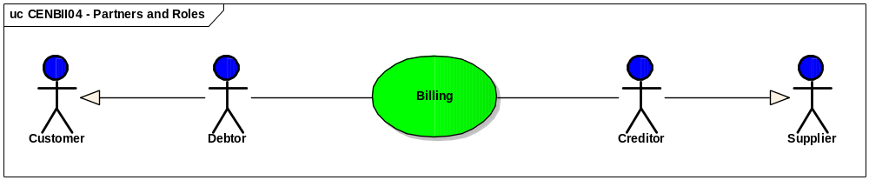

Document flow

A profile is broken down to reuable collaborations that contains transactions. A transaction is an exchange of a document from one party to another. The collaboration may need some logic in between to chose the flow of transactions. Below is shown the Submit invoice transaction that is reused in all billing profiles.

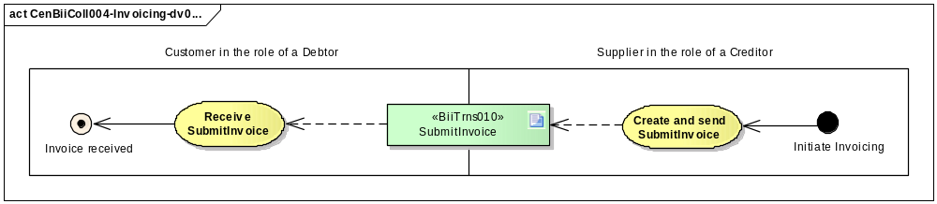

Billing profiles do also specify other transactions like “ResolveInvoiceDispute”, “CorrectWithCredit”, “CorrectWithInvoice”

How to understand profiles
The PEPPOL profile descriptions enrich the CENBII profile with additional restrictions and further guideline of how to implement the profiles. PEPPOL does also provide some profile descriptions that currently are not covered by CENBII. This is profile description for Virtual Company Dossier and usage of catalogue in the preawarding procurement.

CENBII profile descriptions
The CENBII profile descriptions are structured into the following template:

Section | Description
- Preable | Brief formal preable
- References | Reference to other documents
- Business benefits and requirements
- Business benefits | The main business benefits to be gained by implementation of this profile
- Business Requirements | Specific requirements regarding this profile
- Profile detailed description
- Context | The context for the desctription devided into six categories
- Business process in scope | Usecase diagram for the profile
- Partners and authorized roles | Description of the roles involved
- Choreography of business collaborations | Description (Collaboration diagram) about the collaborations involved.
- Profile business rules | List of applied business rules for the profile
- Business Collaboration(s) detailed description | Descriptions of collaborations into transactions
- Transaction(s) detailed description | Sekvensdiagram for the involved transaction
- Transaction data models | Reference to the models involved
- Transaction | Descriptiotn of the transactions

PEPPOL profile descriptions

The PEPPOL profile descriptions take basic in the European Interoperabillity Framework. They describes how interoperability are achieved and how the CENBII profile Descriptions are used. The focus is in particular the area where there is a need for further requirements and restrictions.

Profile relationships
Some profiles has prerequisites that another profile has been perforned before, this could be in paper or elektronically. For instance take the profile basic procument basic in that the itemnumber of the purchased goods or services is kown by the buyer. This requires a catalouge that can be exchaged by the some of the catelogues profiles (e.g. BII01) for getting the full business benifits.

By choosing a profile that covers more than one business process (eg. Basic procurement, BII06) the stakeholder ensures more business benifits than by chosing smaller profiles. On the other hand smaller profiles ensures more flexibilly for the stakeholder and the economic operator.

The picture above shows the relationship of profiles and the business process and PEPPOL package they belong to.

How to implement profiles
The PEPPOL Profile specifications specifie the exact requirements to achieve interoperability for a certain CENBII Profile. The PEPPOL profile description restricts the CENBII profile and enhances the specification for implementation. Taking basic of the European Interoperabillity framework the profile descriptions describes the requirements for each level in a PEPPOL context. The PEPPOL profile specification has the following chapters:
- Preamble
- Introduction
- Legal Interoperabillity layer
- Organisational interoperability layer – organization
- Organisational interoperability layer – process
- Semantic interoperability layer
- Technical Interoperability Layer - Process and Semantic Implementation
- Technical Interoperability Layer – Transport
- Technical Interoperabillity layer – eSignature validation
- Annex

The specification must be matched with the pilot execution plan for the specific country and industry a mapping of requirements must be made. This is in particular crusial the semantic interoperability.

Semantic interoperability in profile implementation

To achieve semantic interoperability by implementing CEN ISS WS / BII invoice in profile 6 it is required cooperation on several levels.

Message Level
Peppol implementation is based on BiiCoreTrdm010 Invoice data model. This Core data model is a subset of BiiFullTrdm010 Invoice which is again a subset of the large UBL 2.0 Invoice. The figure below illustrates how BIICore Invoice is built up in relation to BIIFull Invoice and UBL 2.0 Invoice. Parties that implement the message must adhere to the specifications of the Core model. If there is a need to use the data elements that are beyond the Core model, then it must be use a separate agreement. Interoperability with one interaction partner will be archived, but not with the next one. It is therefore not recommended to go beyond the Core model. The best way to maintain interoperability on the message level is to affirm that the Core is the one for anyone who implements this. If there is any need for more data elements beyond the Core it should be report to CENBII WS for review. CENBII WS determines whether the Core should be expanded or if necessary reduce. It is crucial to have a permanent and operational WS like CENBII who have responsibility for maintaining the format so that semantic interoperability is preserved and the format will live in the future.

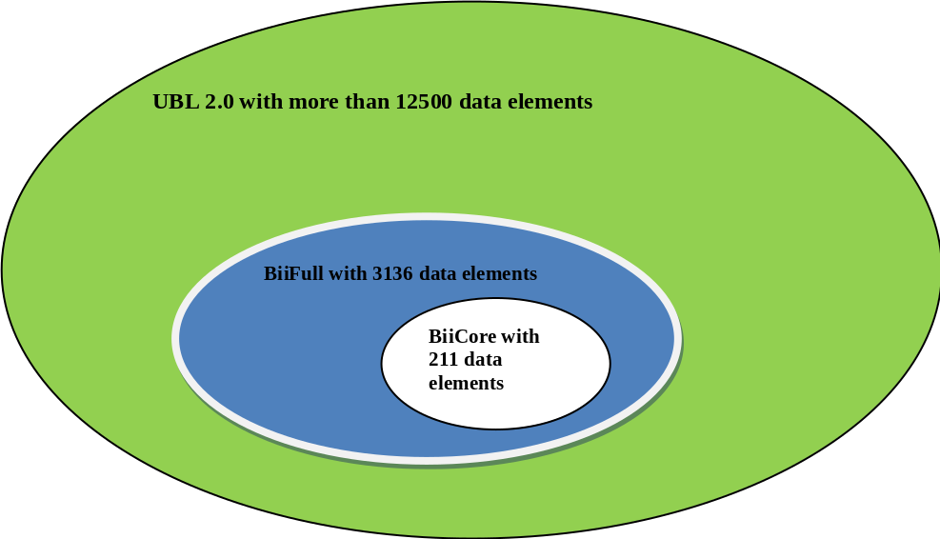

It should be noted that CENBIIs delivery focuses on the data model and does not have a Schemas for validation. All validation must be done through the UBL 2.0 Schemas. This means that it is not easy to detect if a partner uses the data elements that are beyond the Core. As long as the data elements stay within the UBL 2.0 the validation will be appropriate. Schema validation may therefore be a little too generic and it should perhaps be tightened in by creating Schema specific to Core so that it achieves better interoperability.

Data item level
It is not a given that if both interaction partners are using the same Core format then they will achieve interoperability automatically. Parties can interpret the data elements in different ways and thus the mismatch occurs when data is exchanged. One is forced to use the data elements in the same way. To achieve it, it is necessary to have a precise description of how the data elements should be used. An implementation guide is therefore crucial for interoperability. Business rules for the format are also a part of an implementation guide.

Code List
A good number of data elements using the code list at attribute level to provide sent data a meaning. Interaction partners must use the same code list to achieve interoperability. It is unfortunately that the code list work is often down priority. It is therefore crucial that the code list work should be put into more focus to achieve semantic interoperability consistently between interaction partners.

CEN BII Code Lists are published on http://spec.cenbii.eu/Profiles/Guidelines/BII_CodeLists-v1.00.xls, and the front sheet shows that most of the codes are populated. The populated ones must be shared and implemented and used the same ways. Reuse of the populated ones open for interoperability. Some are not populated, and those that need to be interpreted by different systems must be shared within PEPPOL’s user community.
Code Lists used for the BiiCoreTrdm010 Invoice data model must be shared between business partners in order to achieve interoperability. The exchange of electronic documents uses the collection of information called BUSDOX for interoperability purposes; codes used in BUSDOX will need to be shared as well.

CEN ISSS WS/BII Profile
Semantic interoperability is concerned establishing a shared agreement about what data is exchanged and its meaning. In bespoke implementation, such as when using EDIFACT, such interoperability is established through bilateral agreements between the business partners involved. The implementation of the solution therefore becomes, to some extent, tailored to the requirement of each pair of business partners.
Consequently, connecting new parners requires implementation costs that must be offset with sufficient volume.

In order to adopte solutions that support using electronic trade with small and medium size enterprises the PEPPOL project adopted the BII specification of business profiles for semantic interoperability. The BII profiles can be viewed as standardized communication agreements between business partners. The objective of the BII profiles is to enable organizations to implement a general interface for exchanging electronic documents, such as invoices. Two organizations that have implemented a BII profile can therefore start trading electronically with minimal or no implementations cost for each new trading partner.

The BII profiles define the following key issues that need to be agreed before exchanging electronic documents.
- Message sequence, this is the definition of what messages each partner should be able to send and receive and in which sequence.
- Message content, defines what information must or may be in a message. For the sender this defineds what information he must provide and what information he can expect the receiver to read. For the receiver this defines what information he may expect and must be able to read.
- Busienss rules, specify the the agreed rules of exchange such as the business commitement that that is established by sending a message such as an order, how values are calculated, what values are allowed and various other issues that er required to ensure that the exchange of messages results in a common understanding between the business partners.

The BII profiles define a minimum level, called Core which is the level of exchange that must be supported by each business partner. The design objective of the Core is to support most common business requirements and all legal requirements that are relevant to cross border trade within EU/EEA. The reference for legal requirements are EU directive but the definition of “most common business requirements” is qualitative and has been established by common agreement of the participant of the CEN BII workshop.
In addition to the Core definition BII recognizes that within individual countries there may be additional legal or business requirements and that there may be additional requirements that apply in particular business relations. The BII architecture enables support for such requirements by allowing bilaterally agreed extentions to the Core.

PEPPOL requirements for semantics interoperability
The Peppol project scope is cross border public procurement.
This project scope implies the following issues.
- Since most public procurement is domestic, organizations may be reluctant to implement solutions that only work for cross border trade. Consequently it is desireable that the Peppol specification can be used for domestic trade as well.
- Public procurement is frequently based on contracts what in many cases result from public tenders. This may place additional requirement on the message exchange. Public procurement also concerns non contractual procurement for lower value purchases.
- The procurement process may need to connect to other business process such as product delivery and financial settlement. This may place additional requirements on the message exchange.
In order to support the above listed issues Peppol applies the extention mechanism as it is defined in the BII architecture.

To establish semantic interoperability BII specifies the following rules for conformance. An organization can claim conformate to a BII profiles either as sender or as receiver. To be conformant to BII the relevant organization must:

As sender:
- Provide all information that is mandatorey in the core message.
- Be able to provide electronic responses or new main documents as specified in the profile.
- Agree to all the business rules specified in the profile.
As receiver:
- Read all information elements that are defined as part of the core message.
- This is to ensure that the sender of the message knows that his information will be read without entering bilateral agreements.
- The receiver may not reject messages if they meet the core requirements. As example he may not reject a message that does not have a value for an optional element.
- Be able to provide electronic responses or new main documents as specified in the profile (there is no response in profile BII04)
- Agree to all the business rules specified in the profile.
Business partners are allowed to bilaterally agree on semantic extentions but those extentions may not conflict with the core profile requirements.

Semantic extentions in Peppol
Business partners that use BII profiles may agree on extentions to the profiles specifications. These extentions can be of various types but the most common ones are the following.

- The partners may agree that an element that is optional in the core specivication should be mandatory. The affect of this is that the receiver will then reject the message if the element is missing
- The partners may agree that the message must contain an element that is outsite of the core, i.e. not defines as optional in the core message.
- The partners may agree on specific relationships between elements, e.g. that for a specific value in elment A, elment B must have a specific value. An example of such are specific formats of addresses or specific financial account information.
- The partners may agree on restricting the data allowed in elements, such as agreeing to use a specific ID scheme even if BII allows other schemas.
The BII specification of extentions states that they must be bilaterally agreed. Meaning that before the partners start using the extentions they must agree on them. Such an agreement can be established if various ways either directly or indirectly. Among possible scenarious for directly agreeing on a bilateral extention.
- The partners may mutually evaluate their requrements and aling them and then specify the extentions.
- One partner may define an extention and make the use of this extention a contractual requirement. An important example of this is a public authority that tenders for a project. The authority can make the use of a specific extention, such as making contract references in an invoice mandatory, a required tender qualification.
- One partner may make it a part of their standard contract for a service that the customer party uses a specific extention. An example of such is that a financial institution may require those that use their invoice collection service to use an extention that makes specific account information required.
- Business partners may, as part of their contracting, agree to use a specific service such as transport or financial service and consequently agree to use an extention provided by that service provider.
In its use of BII extentions Peppol defines that bilateral agreements on using extentions can be established indirectly. That is if business partners individually become members of a business community or a group that requires all members to use a specific extention they may expect that when sending messages to another member of that community that member supports the extention. The most important example of such is the following:
- Domestic legal requirements. By conducting business within a country domain it is espected that a party supports the legal requirement if that country.

Application of Peppol semantic extentions.
Additional processes can be supported by this document by requesting additional information fields or by contractually requesting certain fields to be mandatory (order number, employee number). These additional requirements can NOT supercede or contradict already existing rules or requirements stated in CEN BII profile 4. This is always done by by-lateral contracts like framework agreements, or industry specific requirements like use of specific classification of products.

Peppol implementation of BII is based on the UBL syntax. The UBL messages contain the following elements for identifying the type of the message.
Document root element, for an invoice this is <Invoice>. The root element has several attributes that among other things identify the UBL schema that is used.
ProfileID Profile IdentifierThe profile ID identifies the transaction sequence that the parties can are espected to use. In profile 04 this is only one transaction, the invoice.
CustomizationID The customization identifier identifies the transaction that is being exchanged and defines the transaction level extentions. The BII definition of the ID is urn:www.cenbii.eu:transaction:biicoretrdm010:ver1.0:ext where “ext” is the identification of the extention.
A Peppol semantic extention is a set of business rules and each set is identified with an id. To enable to receiver to validate an incoming messages with the correct rules the extentions that apply to the message are identified at the end of the CustomizationID according to the BII architecture.
In Peppol it is possible to use more than one extention is a single message in which case the extention identifiers are separated with a plus sign. The rule is that the rules that are identified in the customization ID should be applied in the order that they are listed so that an extention may not break the rules of the previous extention.

Peppol extentions are identified according the following schema. Extention identifiers should always be lower case using only the english alphabet and numbers.
cctttnnnn
where
cc is ISO country identifyier. Example is IT for Italy, AT for Austria.
ttt the rule type.
nnnn alphanumeric identifier for each extention.

In addition to the ISO country codes uses EU for all European countries and XX for all countries. European countries are defined as those that are members of EU or EEA.
For rule type Peppol reserves the following type for specific use.
law – Rule tha apply domestic legal rules to documents that are exchanged domestically
gov – Rule used by government agencies.
fin – Rules used by the financial industry.

Example
Extention itlaw0001

This is an Italian general extention that applies to all exchange of invoices within Italy. General extentions are applied by membership, meaning that since the party concerned has registered for business in a given country he has agreed to follow the law of that country. Consequently the law rules need to be issued and managed by an authorized body such as a government ministry.
Extention itgov0001
This is an Italian government extention.
Extention eufin0001
This is an extention that specifes financial requirements that apply to the invoice in cross border trade.
BII has two types of transaction idendifiers one for the core data model and another for the full data model. Extentions that only restrict the use of the core data model may use the core data model specification. If an extention specifies the use of an element that is outside of the core it must use the full data model identifier.

Example
An invoice instance may contain the following header information.
<Invoice xmlns="urn:oasis:names:specification:ubl:schema:xsd:Invoice-2" xmlns:cac="urn:oasis:names:specification:ubl:schema:xsd:CommonAggregateComponents-2" xmlns:cbc="urn:oasis:names:specification:ubl:schema:xsd:CommonBasicComponents-2" xmlns:ccts="urn:un:unece:uncefact:documentation:2" xmlns:ext="urn:oasis:names:specification:ubl:schema:xsd:CommonExtensionComponents-2" xmlns:qdt="urn:oasis:names:specification:ubl:schema:xsd:QualifiedDatatypes-2" xmlns:udt="urn:un:unece:uncefact:data:specification:UnqualifiedDataTypesSchemaModule:2">
<cbc:UBLVersionID>2.0</cbc:UBLVersionID>
<cbc:CustomizationID schemeDataURI="http://www.eykur.is/rules/">
urn:www.cenbii.eu:transaction:biicoretrdm010:ver1.0:itlaw0001+itgov0001
</cbc:CustomizationID>
<cbc:ProfileID>urn:www.cenbii.eu:profile:bii04:ver1.0</cbc:ProfileID>
The above header specifies the following validation procedure.
Validate them message syntax with UBL schema for Invoice version 2.0
Validtate the message BII semantics by using the bii04 schematron file for transaction datamodel biicoretrdm010
Validate with extention rules itlaw0001
Validate with extention rules itgov0001

Using extentions in the BusDox network.
Business partners can discover each other capabilities through use of PEPPOL SML / SMP. By registering receiving capabilities in a PEPPOL library a business states its capability of receiving invoices according to this profile and willingness to receive invoices according to this profile from anyone capable of creating an invoice according to that profile.

The BusDox network uses SMP registries to identify parties and their capabilities. A receiving party may therefore reject messages that contain customizations identifiers that are not registered. Consequently when bilaterally agreeing on using an extention the receiving party must register the full customization ID with the extentions.

Applying extentions in trade
The following diagram describes how Peppol profiles can be used to support cross border trade as well as domestic trade and specific industry requirements.
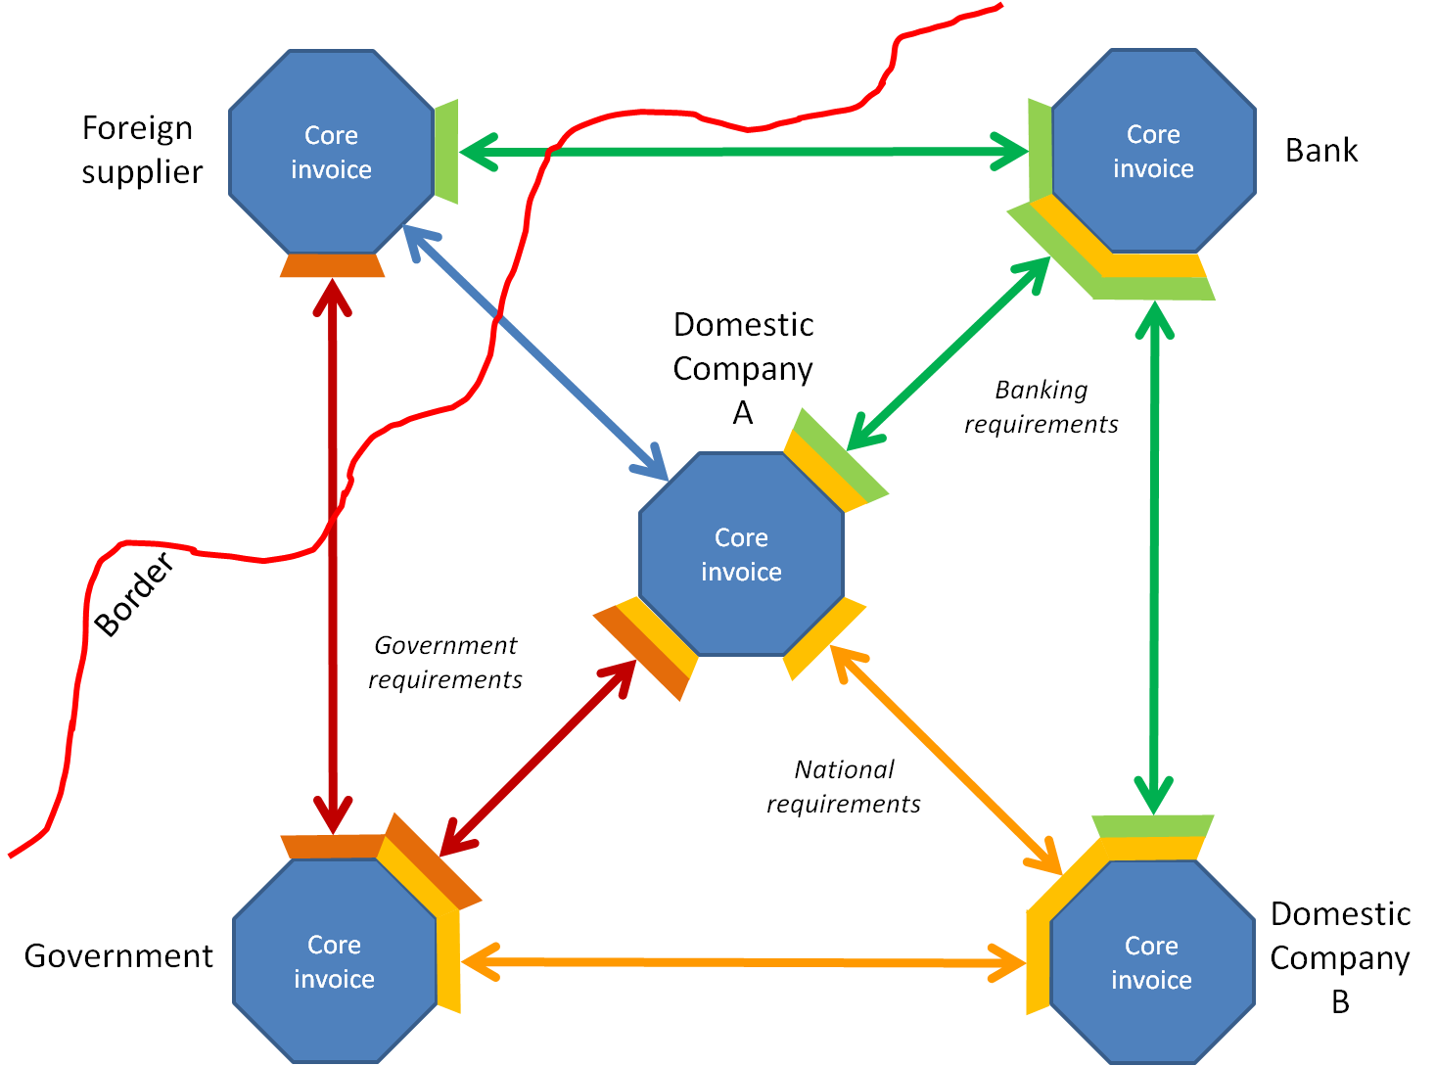

- International procurement with foreign supplier is done by using Core BII transactions.
- Domestically, companies A and B must use the core plus national extention (yellow) which defines legal requirements that apply in that country.
- Companies A and B may buy invoice related services from a bank in which case the bank requires them to use a specific service related extention (green) in addition to the core and the national requirements. The foreign supplier may buy the same service from this bank but then only needs to use the banking service extention, not the national one..
- The government may have specific requirements that it enforces to those of its suppliers that have contractual agreements. Domestic suppliers that have contracts, company A, must then use a government extention (brown) in addition to the national one, a foreign supplier is however not required to use the national extention. The government may also do lower value purchases from domestic companies and accept electronic invoices from them, in which case the government extention is not required but the invoice still must comply with the national requirements.

Interoperability testing.
The validation is carried out in steps according to the BII validation specification in the in the following way.

- Validate with the syntax schema that is identified with the message root element and UBL version ID.
- Validate with BII schematrons provided for the given transaction identifier.
- Validate with BII schematron provided for the profile in which the transaction is used as identified in the Profile ID
- Validate with extentions in the order they are given in the Customization ID.
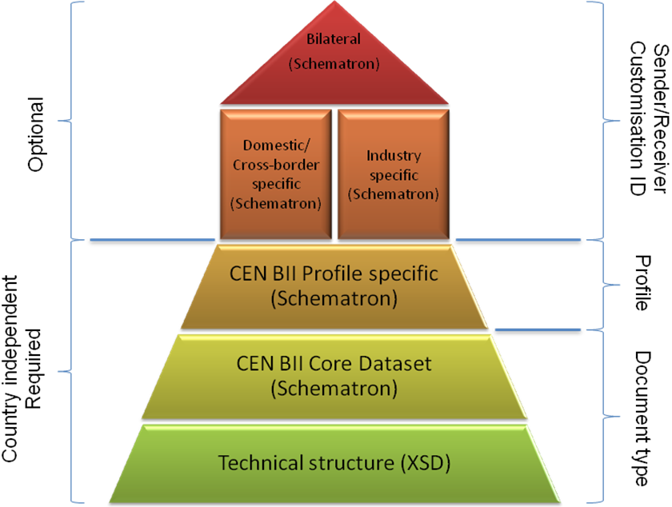

BII provides two sets of data models, core and full. If an extention is in the form of restricing the use of the core data model, e.g. by changing a optional core element into a mandatory element, the BII transaction data model used is still the core data model and is identified as such. If the extention, on the other hand, requires an element that is not listed as optional in the core then the customization id must refer to the full transaction datamodel.

Services that offer transformations between syntaxes for BII must support all the elements of the core data model. Extentionts that are a restriction on the core data model can therefore be expected to be correctly transformed by intermediaries; this can not be relied on when using the full data model.

eCatalogue, eOrdering and eInvoicing context
The exchange of documents in Peppol follows a design that enables open exchange of electronic documents. The exchange of documents contains the following main steps. The exchange of business information in the form of data with agreed meaning and in an agreed sequence.
The methods of delivering this data between the partners.

The process of linking the exchanged data to the internal business processes of the parties.
Compliance with externals requirements, mainly laws.

PEPPOL approches this with an open architecture instead of designing the exchange between the individual parties as has been done with conventional EDI. This requies some specific approaches in desing.

Organizational context
The business objective of electronic procurement is to achieve interoperation between the internal business processes of the sending and receiving organization. These business processes may however be different because of various issues such as the organizational type, size, accounting practices, business culture and various other reasons.

When applying traditional EDI type of electronic document exchange the two parties have usually analysed their processes in terms of data requirements and message choreography and designed the exchange seou so that the businesss processes of the two organizations are aligned. Consequently the implementation has been tailored and linking to additional organizations has required a repetition of this process and another tayloed implementation volume of documents exchanged has limited what connections are economical.

The BII profiles, as opposed to tradition EDI (like EDIFACT), standize the data exchange between the organizations. The profile also set an interoperational conformance rule that when an organizations state that it is conformant to a profile it must not reject documents that meet the profile specifications. The BII profile architecture additionally provides support for bilaterally agreed extentions that allow organizations to agree on additions to the core profile.

This introduces the following key functions for organizational processing of BII documents.
Message handling functions:
- There is a need to verify that incoming message are conformant to the BII specification and any bilaterally agreed additions.
- The received document may need to be pre processed before they can be imported into the ERP system.
- Document archiving for access during internal processing as well as for later retrieval.

Internal processing functions:
- Assigning accounting keys and links to internal processes applied in the corporate system.
- Review and acceptance.

These functions are shown in the below diagram.

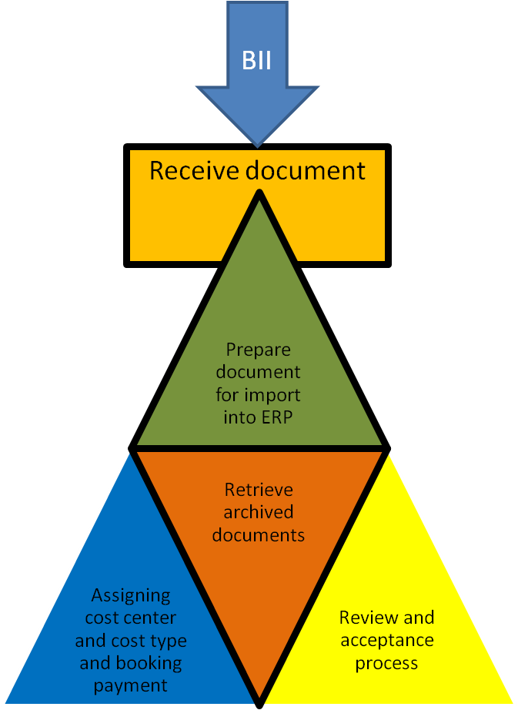

Levels in organizational interoperability
The business relations between organizations differ in both complexity and volume. An organization has many business partners eithar as customers and suppliers or both. The main focus here will be on the suppliers and the processing of documents received.
An individual corporation has many suppliers and the business relations with each vary considerably. The type of suppliers differs but those differences can be arranged along two axis, the volume of exchange and the complexity of the exchange.
- A typical high volume supplier are those that supply items that are integral to the organizaions own value chain, i.e. are used as material in processing the organizaions own service or products. An example of this is medical supplies for a hospital.
- A low volume supplier are those that supply items that are purchased infrequently or ad-hoch. Examples are various maintenance services. A low volume supplier is not necessarily a small organization.
- Complex suppliers are typically those that provide items that require detailed referencing to contracts, item property details or require various other specific processes. A typical supplier of this type is a supplier of contracted works.
- Uncomplicated suppliers are typically those where that deliver items that are not integral to the corporations own output and are of lower total value. Examples are some part of office supplies and irregular purchase.
Electronic exchange can be achieved against these different groups as demonstrated in the below diagram.

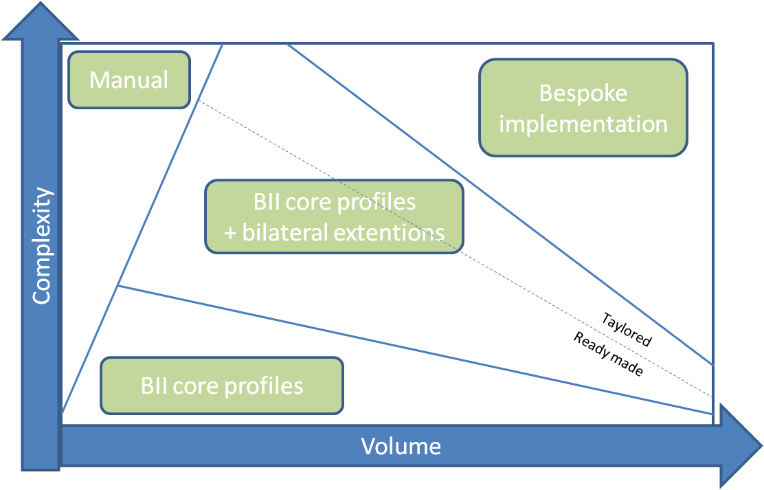
Bespoke Suppliers that have high volume and some or high complexity are those where implementation of bespoke connections have been economical and will remain so. Not in the PEPPOL scope, but BII core is applicable.
BII core Suppliers that have low complexity can be supported with standard BII core profiles even if the volume is fairly high. Suppliers that have very low volume (ad-hoch invoices) and very low complexity can also be intergrated by using BII core profiles. In the PEPPOL scope and handled by the PEPPOL Core Profiles.
BII + extentions Suppliers that have some complexity but not the volume to justify EDI implementations can be supported with BII core profiles plus the addition of bilaterally agreed extentions. Some can be supported with ready made extentions that are reused for many suppliers but some may justify tailor made extentions.These implementations need at minimum to have the volume that justifies agreeing on using a ready made extention and adjusting system parameters accordingly. PEPPOL offers a set of PEPPOL Specific Profiles (ready made) that covers special legal (national) framework- and/or Organisational (Industry or Service) requirements.
Manual There will always remain some business relations where there is some or very high complexity and very low or low volume so that electronic exchange can not be justified. Examples of such can be small contracts for complex works. Not in the PEPPOL scope.
An organization that plans to implement Peppol should analyse its suppliers and organize them into these group and set a strategy on how to implement electronic exchange with each group.
As part of such a strategy would be specify what suppliers should be handled with core profile only and to specify a set of ready made extentions that would be used for selected customers. Examples of ready made extentions can be:
- Special data requirements for suppliers who have a contractual agreement. In such cases the agreement of using the extention would be part of the contract made with the particular supplier.
- Special data reguirements for specific services. Example of such is if suppliers require specific handling such as for payment the relevant data requirement can be specified as ready made extentions and used againt any supplier who requires the use of that payment service.

Organisational Issues
The following section describe the message handling functions that need to be handles in some way in order to intergrate the standardized BII document with the organizations internal data structure.

Process received document
When an electronic BII document is received via the Peppol network and based on BII comformance, the main objective is to ensure that the BII document is correct and contains the information required for importing it into the ERP system and/or process it with internal business rules such as for allocating account keys or for internal routing.

Prepare document for import into ERP system
The UBL message has a data structure that is not identical to the data structure of the ERP system into which the data needs to be processed. The difference can vary but most commonly it is one or more of the following differences.
- The BII message contains more data than is used in the ERP system.
- The format of the data in the BII message differes from the format in the ERP system. An example is date format.
- The ERP system requires some data that is not in the BII message and originates from within the organization. Example of such can be type codes and other parameters.
The import of the message content into the ERP system may differ and depend on what is functionality is available in the ERP system. Examples of most common mentods of import are the following.
- Reading the BII document directly into the ERP system.
- The ERP system provides import functions for another message format in which case the BII message needs to be transformed into that format before importing into the ERP system.
- Reading the BII message data into tables that have identical data structure to the ERP system and carry out actions on those tables before reading into the ERP system.

Archiving received document
The BII profile conformance rules require the receiver of an electronic document to be able to process all information that is defined in the BII core document data model.

This may however be more information than what the receivers ERP system requires or supports. The recommended approach to process the additional information is to provide access from the ERP system to the original document that can be displayd either by using stylesheet or by generating a image file from the original XML document and store that internally.

This process is very similar to the process of using scanned invoices, with or without OCR scanning in the way that the electronic document image replaces the scanned document image.

Since the receiver is required to process all the core information is is recommended that the ERP system interface shows a flag if the document contains information that is not imported into the ERP system and thus alerting the user that he should check the image file.

For auditing purposes the document image can also be viwed, keeping in mind that the actual original is the XML document received, not the image of it. Archieving is for PEPPOL seen as a context, the subject it selves is out of scope.

Internal processing
Specifying internal processing of electronic documents within an organization is not within scope of Peppol. However, since the automation of those processes is the overall objective of using electronic document exchange, it is necessary to identify and briefly discuss the main aspects of those processes and how they relate to the electronic document, as well as providing some recommendation that are likely to improve flexibility and increase the propability of successful implementations. The internal processing handles the following issues:
- Matching a received document to the internal flow. This includes assigning cost center, matching an invoice against the order etc. For being able to do this automaticly, some links to the external exchanged document must be provided. Each profile description will list requirements that manage this.
- Accepting the document. When the document is routed to the right person due to the internal process flow this person decides whether or not it can be accepted. Sometimes this can be don automaticly (eg. order to invoice match) and som times som tools can validate the document in advance to only a minimus things need to be validated.
- Message handling functions. This includes collecting the data to be sent from the various systems and manual process in the internal system, Creating the document in the ERP system and sending the document through the right channel.

Industry specific processing
Different industries may require additional processes such as contract references in public procurement, production lot and quality details for items such as medical supplies as well as information detail needed for specific delivery information or payment settlements.
Particular business situation may require additional information in order to support such requirements.

